Following are the Steps to create commercial text file from sample commercial excel file.

Step1. Fill the data in all the mandatory fields which is highlighted in RED in the sample commercial excel sheet as below.

For Ex: below are some examples how to fill data

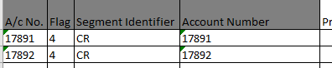

Finale formula will automatically calculate as highlighted in yellow mark once you fill the data as per the formula provided in the final formula sheet.
(Note: No Need to create different sheet we suggest you to use the same sheet which is provided by us for smooth functioning)

Step 2: Kindly Refer Guide or glossary of Commercial Bureau - Input File Format which is provided by us to fill the correct form and format of data in the excel sheet provided by us for reference.

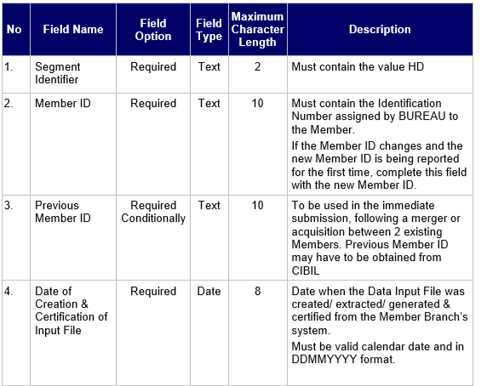

Step 3: Kindly Copy the first 3 column and last column which is finale formula data from every sheet and paste into the sorting sheet as below screenshot.

COPY : (Copy from every sheet where data is present)

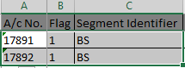
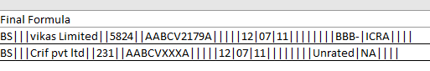

PASTE:(Paste into the Sorting Sheet paste as a value)

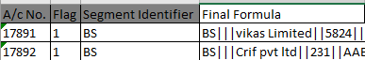

Step 4: Copy and Paste all the segment data into the sorting sheet as above step 3.
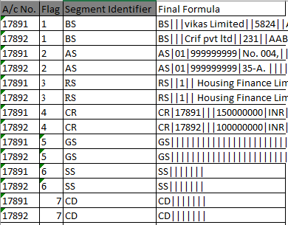
Step 5: Select All data in the sorting sheet and go to the Data TAB in excel sheet and click on sort .

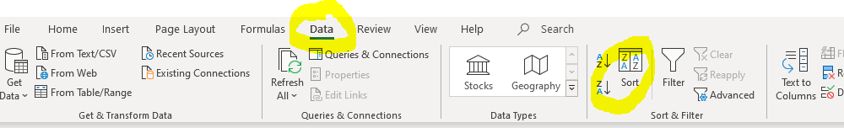

Step 6: After that add 2 levels first by A/C No and then by Flag or column A and Column B as below.

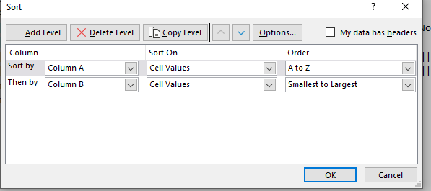

Step 7: Click on OK Button, then click on 2nd option which is sort numbers and numbers stored as text separately and click OK.

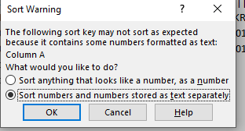
Step 8: you will get the data sorted as below.
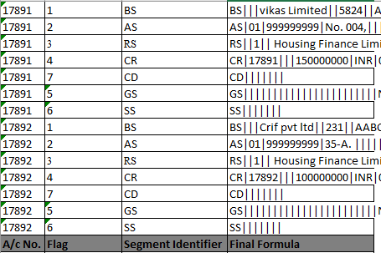

(Note : If sorting not done properly then go for step 13 to step 23 to do the sorting step correctly )

Step 9: Insert 1 row above the first row and paste as value the Header (HD) segment data in the 3rd column as below.

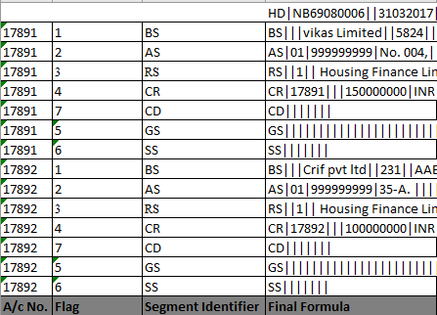

Step 10: paste as value the Trailer (TS) segment data in the 3rd column as below.
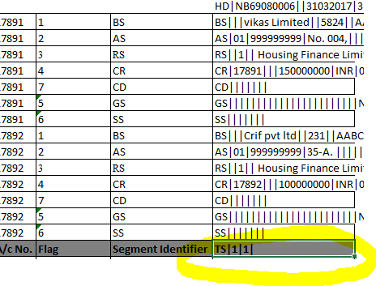

Step 11:Copy the data of 3rd column and paste in a notepad as below .

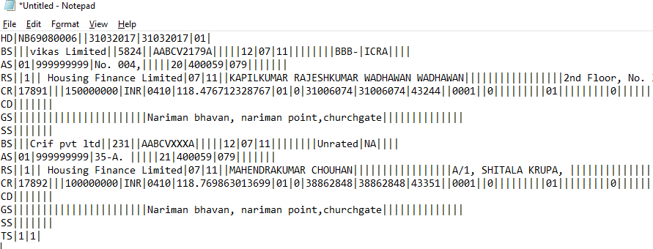

Step 12:Save the notepad file as a name you want or as per member ID name and share in the FTP portal as like earlier.

IF SORTING IS NOT PROPERLY DONE

Step13: Insert 2 columns after after account number and FLAG column as below

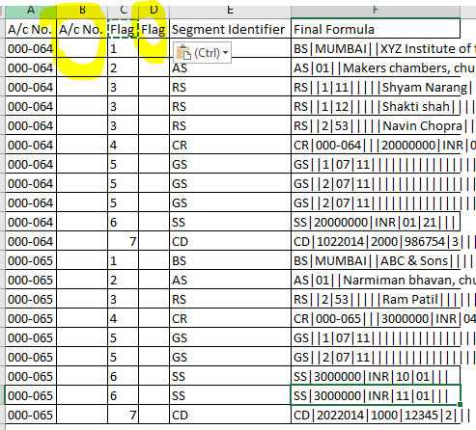

Step14: Insert formula =TRIM(A2) OR =CLEAN(A2) in the column B Also do the same in column D with formula like =TRIM(C2) OR =CLEAN(C2) and click ENTER

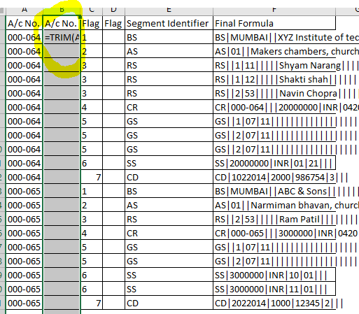

Step15: If value came to the column then drag it till the last row end wherever value present so formula will came till last row, if formula is not working then could be reason that the column is in TEXT format you need to covert that column to GENERAL as below .

Step16: Click on the TEXT TO COLUMNS option in the DATA TAB as below.

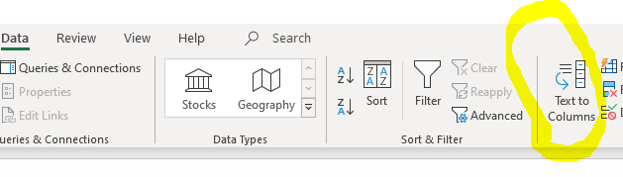

Step17: You will see a dialogue box then selected delimited and next button as below.

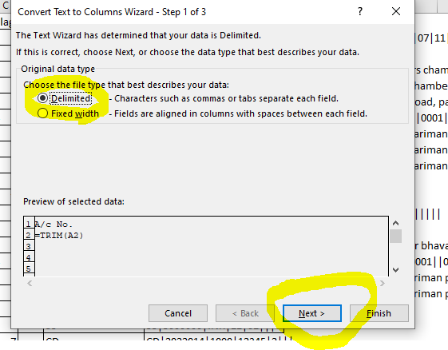

Step18: Again Click the next button without selecting any option as belows.

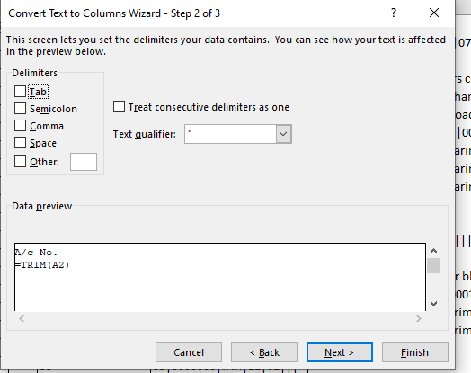

Step19: Select GENERAL Option and click the FINISH button as belows.

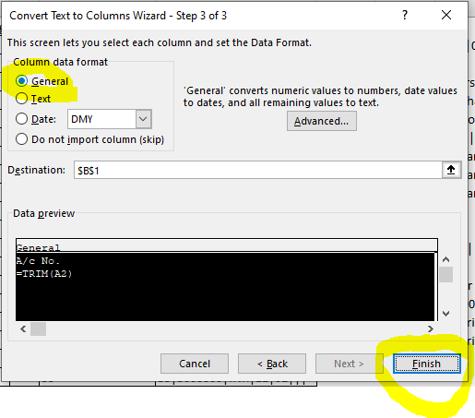

Step20: After clicking FINISH button the value will come to the first row of column then DRAG till the end as below.

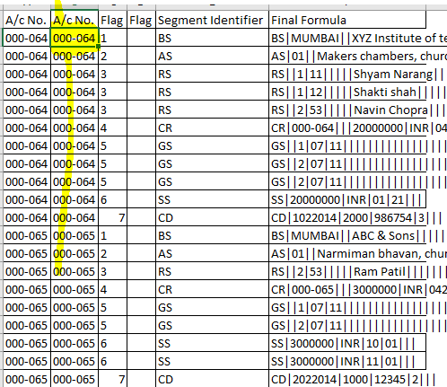

Step21: Do the same Step in newly inserted FLAG column which is Column D as below.

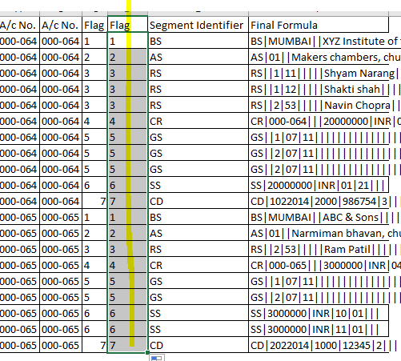

Step22: Then COPY and PASTE as values in both the newly inserted column which is column B and column D

Step23: Delete the previous column which is column A and column C then the data will show as below which removes all the spaces and ready for the sorting as below.

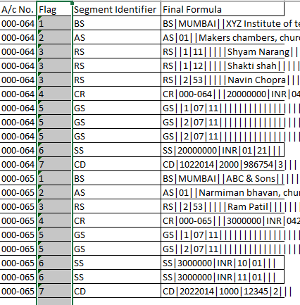

Step24: Do the same steps which was earlier use for SORTING step 5 to step 12.

